**CHAPTER- I**

1. **INTRODUCTION**

**1.1** **PLACEMENT PATTERN EVALUATION- AN OVERVIEW**

The project entitled as “Placement pattern evaluation” is used to evaluate the pattern for placement. Placement pattern evaluation is an effective way to evaluate the patterns for various companies involved in the placement. The project also evaluates the different questions involved in each pattern. The questions are evaluated for all the academic years respectively. The pattern is finally sent as an email to the respective students involved in the placement scenario. Based on the patterns generated the mock test will be conducted for the students. The questions will be shuffled for every student. The report is finally generated based on the test attended.

The project thus helps the students to effectively prepare for an interview. The software also helps the students to reduce the time spend on searching the patterns and questions for different companies during placement.

**1.2 OBJECTIVES OF THE PROJECT**

The objectives of the project is to-

* Develop a database of patterns for each company
* Add related questions for each pattern
* Prioritize the most frequently asked question
* Provide the ability for the teachers to view the pattern and teach the students accordingly
* Automate the process by sending the patterns to respective students accordingly.
* Mock exam and tests can be done based on the pattern.

**1.3BACKGROUND STUDY**

**1.3.1 EXISTING SYSTEM:**

In the existing system, the placement company names and the details of the student will be available. The student gathers the patterns and the questions by referring to different website. The time taken for analyzing the patterns requires more time. Once the pattern is evaluated by the student the students starts referring to the related questions. The time consumption for this process is comparatively more.

**CHAPTER-II**

1. **SYSTEM ANALYSIS**

**2.1 PROPOSED SYSTEM:**

The proposed system evaluates the pattern of different companies and the related questions. Based on the patterns generated the mock test will be conducted for the students. This reduces the time for the students, instead of searching the patterns in different websites.

**2.1.1 DEFINING THE PROBLEM:**

Placement system should not be just for displaying the placement dates and for the company names. It should provide the students with the patterns and questions involved in the placement for the respective companies..

* Reduces the time for the students, instead of searching the patterns in different websites.
* It conducts tests for the students based on the pattern.
* A report is generated based on the marks.
* Helps the students to effectively prepare for an interview.

**2.1.2 DEVELOPING SOLUTION STRATEGIES:**

**Top-down** strategy of information processing and knowledge ordering, mostly involving software, but also other humanistic and scientific theories. In many cases top-down is used as a synonym of analysis or decomposition. The system incorporates the following aspects.

**MODULES**

**ADMINISTRATOR MODULE**

* + - Admin Login or Faculty Login
    - Company Pattern Setup
    - Company Question Setup
    - Test Setup
    - Student Report

**STUDENT MODULE**

* + - * Student Login
      * Take Test
      * Report

**DESCRIPTION OF MODULE**

**ADMIN LOGIN:**

In the Admin login, the administrator has to enter the username and password to login.

**COMPANY PATTERN SETUP:**

In the pattern module, the faculty can add pattern of various companies involved in the placement.

**COMPANY QUESTION SETUP:**

In the question module, the questions related to the pattern of various companies are added by the faculty.

**TEST SETUP:**

Based on the pattern and question of the companies, a mock question paper is set for the students involved in the placement.

**STUDENT REPORT:**

Based on the marks of the students, a report is generated.

**TAKE TEST:**

It allows the students to take test after viewing the patterns and questions.

### 2.2 SYSTEM SPECIFICATION

#### 2.2.1 APPLICATION SPECIFICATION

In 3-tier architecture, there is an intermediary level, meaning the architecture is generally split up between:

* A client, i.e. the computer which requests the resources, equipped with a user interface (usually a web browser) for presentation purposes.
* The application server (also called middleware), whose task it is to provide the requested resources, but by calling on another server.
* The data server, which provides the application server with the data it requires.

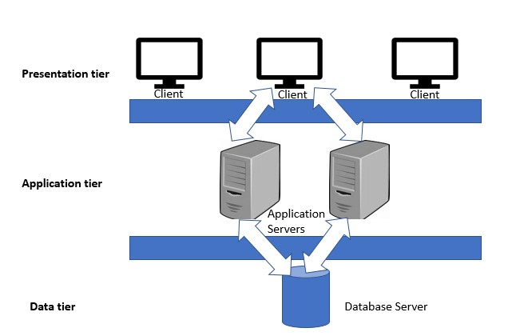

#### 2.2.2 HARDWARE SPECIFICATION

The components of the computer such as electrical, electronic and mechanical units are known as the hardware of computer. The input, output unit and central processing unit (CPU) are called as hardware. Thus hardware is the equipment involved in the functioning of a computer.

##### REQUIREMENT

* CPU : Intel i5 CORE
* RAM : Minimum of 4GB RAM
* Hard Disk : 10GB or More
* Monitor : 15”CRT or LCD monitor
* Keyboard : Normal or Multimedia

#### 2.2.3 SOFTWARE SPECIFICATION

It deals with defining software resource requirements and prerequisites that needed to be installed on a computer to provide optimal functioning of an application. These requirements or prerequisites are generally not included in the software installation of package and needed to be installed separately before the software is installed.

##### REQUIREMENT

* Operating System : Windows 8 / 7
* Front End : Java
* Framework : Spring Boot with MVC
* Tool : Eclipse IDE
* Database : MySQL

**2.2.4 SOFTWARE FEATURES**

**FRONT END**

**JAVA**

Java is general-purpose programming languages that is class-based, object oriented, and designed to have a few implementation dependencies are possible. It is intended to let application developers write once, run anywhere, meaning that compiled java code run on all platforms that support Java without the need for recompilation. Java applications are typically compiled to byte code that can run on any Java virtual Machine. It commonly runs in secure, sandboxed environment to provide many features of native application through being embedded in HTML pages.

**BACK END**

**MySQL**

Microsoft SQL Server 2000 is a full-featured relational database management system (RDBMS) that offers a variety of administrative tools to ease the burdens of database development, maintenance and administration. In this article, we'll cover six of the more frequently used tools: Enterprise Manager, Query Analyzer, SQL Profiler, Service Manager, Data Transformation Services and Books Online.

### 2.3 COST ESTIMATION AND SCHEDULING

|  |  |
| --- | --- |
| **DESCRIPTION OF TASK** | **NO OF DAYS** |
| Abstract | 2 |
| Problem Statement | 2 |
| System Requirements | 2 |
| Design | 15 |
| Coding | 22 |
| Implementation | 5 |
| Testing | 10 |
| Reports | 10 |
| Deployment | 4 |
| Scope | 2 |
| **Total** | 74 days |

Software cost is related to many variables such as Human, Technical, Environment and

Effort applied to develop it. To estimate the effort needed for the software project, Function Point Analysis (FPA) and COCOMO model are used to predict the size and cost of developing the system. Function points are derived using an empirical relationship based on countable measures of software’s information domain and assessments of software complexity. COCOMO, Constructive Cost Model, is a good measure for estimating the number of person months required to develop software. COCOMO consists of a hierarchy of three increasingly detailed and accurate forms. The first level, Basic COCOMO is good for quick, early, rough order of magnitude estimates of software costs, but its accuracy is limited due to its lack of factors to account for difference in project attributes (Cost Drivers). The COCOMO cost estimation formula is

E = c*size k

Where, E = effort in person-months. The effort measure helps to make estimates like the number of person months that will take for the project to execute. The size estimate is converted in to effort estimates.

c = 3.0 for semidetached mode k = 1.12 in semidetached mode

Size= (SLOC)/1000=3.0

Thus the effort for making Android College Campus application is 10.31 pm.

D = a*Eh

Where

D = Development time in chronological months a = 2.5 in semi-detached mode h=0.38 in semi-detached mode

No of days worked = 74 days

1 day work = 8 Hours

Total no of hours = 592 Hours

Cost for 1 hour = 100 ₹

Total number of cost =Total number of hours*cost for 1 hour = 592*100 = 59,200/- Therefore total cost of the product is ₹ 59,200/-

**2.4 FINAL OUTLINE OF THE SYSTEM:**

The system provides a user friendly interface. The students can view the pattern and questions of various companies easily. The test helps the student to effectively prepare for the interview. This reduces the time involved in searching.